Problem : as we learn about building helm chart and templates. We also learn about using values.yml file to update our resource using set parameters.

Below mentioned is the Github link which contains manifests https://github.com/gopal1409/ibmmanifestsep.git

1. To deploy my sql database this are manifest

a. pv.yaml

b. pvc.yml

c. secret.yaml

d. configmap.yml

e. mysql.yml

f. mysqlsvc.yml

Solution

g. Create an helm chart for mysql deployment

h. we are frequently updating the mysql image version using values.yml do the same

i.

Second Problem

There are another two manifest file for front end.

1. Frontend.yaml

2. Fronendservice.yaml

Solution

1. Create another helm chart for frontend deployment

2. we are frequently updating the frontend service values.yml do the same. Try with load balancer nodeport and cluster ip

For mysql:

Chart.yaml

apiVersion: v2

name: mysql

description: A Helm chart for K8s

type: application

version: 0.1.0

appVersion: "1.16.0"

values.yaml

image: mysql:5.6

Console output:

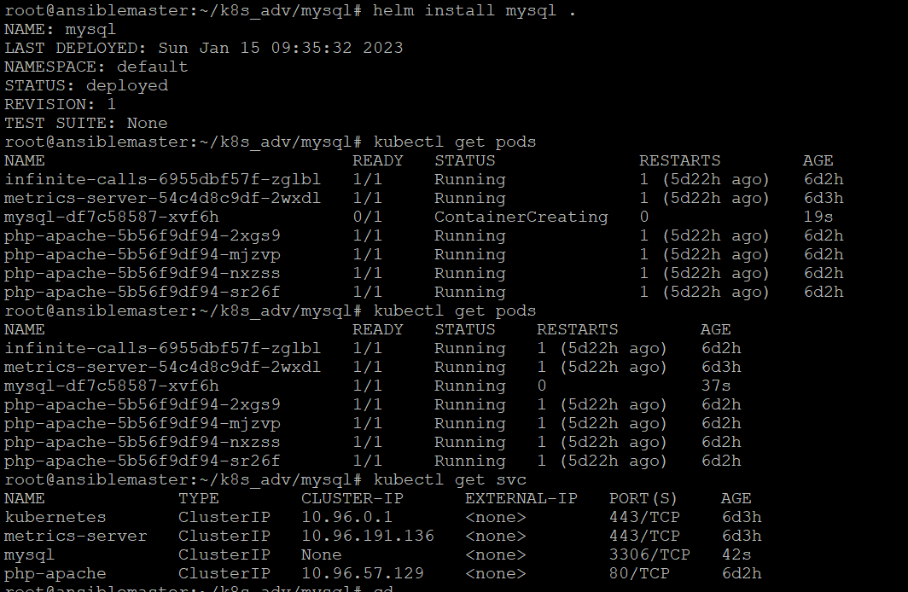

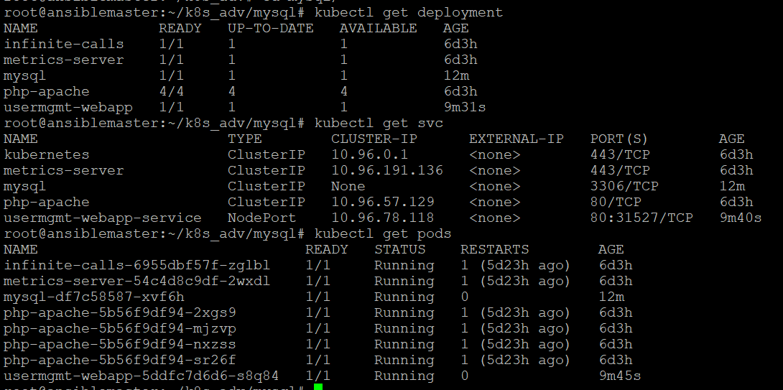

For frontend:

Chart.yaml

apiVersion: v2

name: frontend

description: A Helm chart for K8s

type: application

version: 0.1.0

appVersion: "1.16.0"

values.yaml

service: LoadBalancer

Console Output:

